**Background**

It’s a van hire company called TopHire. It’s purely fictional of course. Their business system (HireBase) captures the rental information, including the customer information. HireBase has a fleet database where all vans are maintained. HireBase contains only 3 tables:

1. Customer: contains 100 customers, e.g. name, data of birth, telephone number, etc. A column called CustomerId uniquely identifies a customer.
2. Van: contains 20 vans that Top Hire operates. It’s their fleet. Contains the registration number, engine size, van size, colour, year of manufacture. The unique identifier for each van is the registration number.
3. Hire: contains 1000 hire transactions since 1st Jan 2011. Every hire transaction stores: who the customer was, which van was rented out, the date it occurred, number of days and various hire fees/charges (the van, sat nav, insurance, damage waiver and total bill). For each transaction we have Hire ID, which is a unique identifier in this table.

The data warehouse contains 4 tables:

1. Date dimension: contains every single date from 2006 to 2016.
2. Customer dimension: contains 100 customers. To be simple we’ll make it type 1 so we don’t create a new row for each change.
3. Van dimension: contains 20 vans. To be simple we’ll make it type 1 so we don’t create a new row for each change.
4. Hire fact table: contains 1000 hire transactions since 1st Jan 2011. It is a daily snapshot fact table so that every day we insert 1000 rows into this fact table. So over time we can track the changes of total bill, van charges, satnav income, etc.

**Create the Data Warehouse**

* So now we are going to create the 3 dimension tables and 1 fact table in the data warehouse: DimDate, DimCustomer, DimVan and FactHire. We are going to populate the 3 dimensions but we’ll leave the fact table empty.
* Now you can see that the 3 dimensions have been populated. And the fact table is created and empty, ready for us to populate it.

**Build the SSIS Package to Populate the Fact Table**

* First I show you how it looks when it’s done. This is the overall workflow we are going to build:

[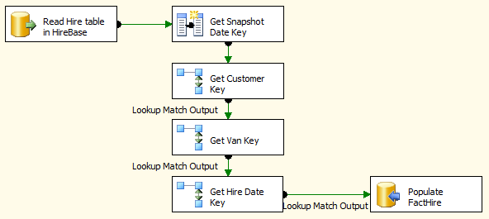](https://dwbi1.files.wordpress.com/2012/05/workflow1.png)

1. Read Hire table in HireBase
2. Get Snapshot Date Key: we get today’s date and convert it into an integer as Snapshot Date Key. FactHire is a snapshot fact table. A periodic snapshot fact table. Which means that every day we populate the fact table with 1000 rows like this:Next week, on Monday 28th May, we insert 1000 rows to the fact table, which is all the rows in the Hire table. Then on Tuesday 29th May we insert 1010 rows. Because there would be 10 new hire transactions in the Hire table in HireBase system. The 1000 “old” rows might change as well on Tuesday, not all of them will be the same as Monday. Perhaps there are 10 rows which are modified, the amount/fees changed, etc. Whatever the condition of the Hire table on Tuesday, we are taking all rows in put them into our data warehouse. And we do this every day. We every day, put whatever is in the Hire table into FactHire. That’s what Periodic Snapshot fact table means.Hence in a periodic snapshot fact table we have a “Snapshot Date”. Meaning: the date when we captured the source table. Or, the date when these 1000 rows were inserted into this fact table. The value of this snapshot date is today’s date (the date the ETL runs). The date the load happens.
3. Get Customer Key: from Hire table we get the Customer ID which was involved in the hire transaction. We then go to the Customer Dimension to get the Customer Key for this Customer ID.
4. Get Van Key: from Hire table we get the Registration Number which was rented out in the transaction. We then go to the Van Dimension to get the Van Key for this Registration Number.
5. Get Hire Date Key: from Hire table we get the Hire Date, which is the date when the hire transaction happened. We then go to the Date Dimension to get the Date Key for this Hire Date.
6. Populate FactHire: After we get all the required dimension keys, we insert the rows into the FactHire fact table.